SOFIE LAYTON
ARTIST
www.sofielayton.co.uk

ARTS PRACTICE, PROJECTS & COMMISSIONS

^{13 July –}
^{19 Aug 2018} The Heart of the Matter exhibition 2018 – RWA Bristol and Centre space.

24 Feb –
6 May 2018 The Heart of the Matter exhibition 2018 – Great North Museum Newcastle. Bringing together art and technology, The exhibition honours the stories that have been shared through the workshop process and explores the link between our medical and our poetic hearts through a series of original artworks. Created and curated by Sofie Layton. See press and website http://www.insidetheheart.org

2016-2018 “Making the Invisible Visible” installation presented at the Bristol Biomedical Research Centre Launch RC launch and The Culture, Health and Wellbeing International Conference Bristol 2017
The installation with 3D-printed models of congenital heart disease is accompanied by a soundscape, The piece was originally created by Sofie Layton during her residency at Great Ormond Street Hospital for Children, with Dr Giovanni Biglino (Bristol Heart Institute) and sound artist Jules Maxwell. http://sofielayton.co.uk/installations.43.html

Nov 2016 | It’s Just a Pain – site-specific installation in St Pauls church Bristol as part of ‘Feel it Festival’ – re-working of ‘Making the Invisible Visible’ Under the Microscope.  http://www.ideasfestival.co.uk/wp-content/uploads/2016/09/FEEL-IT-FEST-PROGRAMME_webversion.pdf
Oct 2016 | In Isolation - site specific installation GOSH as part of Bloomsbury Festival. http://bloomsburyfestival.org.uk/events/event/in-isolation/
2016 - 2019 | The Heart of the Matter - A transdisciplinary project conceived by artist Sofie Layton and Dr Giovanni Biglino (Bristol Heart Institute) An interdisciplinary exploration of the heart, its narratives and forms, with a participatory process at its core. Working with cardiovascular centre’s in London, Bristol and Newcastle, the project will lead to a public exhibition tour in 2018 Wellcome Trust Public Engagement large award. Arts Council England, Blavatnik Family Foundation, Above and Beyond . www.insidetheheart.org
2016 - 2017 | MILK – artist residency Neo Natal Intensive Care Unit (NICU) - Evelina London Children’s Hospital, to imbed a creative methodology with parents/staff on the unit. The creation and installation of a series of screen-printed artworks that reflect the parent and child’s’ journey through the unit. Funded by Guys and St Thomas’s Hospital Trust.
2015 - 2016 | Under the Microscope - an arts research project conceived and led by artist Sofie Layton. The work explores how children and their families interpret medical information and understand disease. It culminated in a series of exhibitions and installations made in partnership with clinicians, researchers, patients and their families at Great Ormond Street Hospital (GOSH) April 2015 – April 2016. Wellcome Trust arts award. http://www.sofielayton.co.uk/installations.43.html
2014 | REST - A sound and visual installation. R&D for an arts collaboration with bereaved and pre-bereaved parents created in partnership with SLOW, Graeae Theatre Company and Richard House Hospice. conceived and led by artist. Arts Council funded. http://www.sofielayton.co.uk/installations.38.html
2014 | Puffball – Roundhouse Circus fest. Directed by Mark Storor. Costume Designer Artist Collaborator. Project devised with LGTQ young people.
2013 | Bedside Manners – Installation at Evelina Children’s hospital, working with parents and sick children funded by Guys and St Thomas hospital trust. Devised small intimate art activities at the bedside. Embossing screen-printing and embroidery shared stories and recorded to create a soundscape with composer Jules Maxwell. http://www.sofielayton.co.uk/installations.34.html
2012 - 2013 | Bedtime Tales – community state bed installation for Hampton Court Palace created from stories of the most unusual place that you have ever slept in. Recorded peoples stories and worked with composer Jules Maxwell to create a soundscape created illustrated embroidered books and details with Stitches’ in Time. http://www.sofielayton.co.uk/installations.33.html
2012 | Voyage – Costume designer for large-scale outdoors performance for cultural Olympiad Birmingham. Designed costumes for 150 people.
2011- 2012 | Commission - Courtyard fountain flowers installation in brass, private collector USA. Using in brass and 23.5 carat gold leaf.  http://www.sofielayton.co.uk/commissions.31.html
2011 | Ironman - As part of the cultural Olympiad With Out Walls programme commissioned by Graeae to design and create an outdoor touring show based on Ted Hughes Ironman featuring a 5-meter tall Ironman puppet operated by a wheelchair user that opened in May 2011. Designer http://www.sofielayton.co.uk/performance.19.html
2010/2012/2016 | The Garden - an outdoor site sensitive performance directed by Jenny Seally with a devised script by Alex Blumer . Costume and set Graeae Theatre/ Strange Fruit as part of Greenwich and Docklands Festival (GDIF) Later recreated for Paralympics London and RIO Brazil as part of the Cultural Olympiad. http://www.sofielayton.co.uk/performance.25.html
2009 - 2010 | FOR THE BEST- Unicorn Theatre, installation performance directed by Mark Storor devised with company. Won the TMA award for best Children’s Theatre 2009 and was reworked for the Unity theatre Liverpool November 2010. Artist / Designer. http://www.sofielayton.co.uk/performance.18.html
2009 | AGAINST THE TIDE – Strange Fruit / Graeae site-specific show for Greenwich and Docklands festival (GDFI) toured to National Theatre in 2010. Set and Costume Designer. Developed workshop programme with adults and young people with learning difficulties, which feed into set design. http://www.sofielayton.co.uk/performance.21.html
2008 - 2009 | Feast Programme – “5 Palaces, 5 Historical Periods and 5 Artists create a wonderful and playful insight into the world of food, ritual and feasting through the ages.” Developed a programme with the HRP OCI Team and different partner organisations.
2007 | REALITY ESTATE- Friction Arts Birmingham. Site- Specific promenade performance, installation and costume designer. Devised and created with community participants. http://www.sofielayton.co.uk/installations.14.html
2006 - 2007 | THE FIELD OF FLOWERS - a sculptural commission to mark the 10th anniversary of Princess Diana’s death. Over 10 weeks a series of 10 Giant Dandelions were created which involved over 6000 people gold leafing a flower as a tribute to Diana. Installed in front of Kensington Palace. http://www.sofielayton.co.uk/commissions.7.html
2006 - 2008 | WITHIN THE WARDROBE- working as the artistic director and using the Royal Dress collection at Kensington Palace, I worked with, elders, families and schools’ groups to explore peoples, memories and stories of clothes. Culminating in an exhibition with a team of artists I also developed a programme of workshops to run along side the exhibition.
2006 - 2007 | DRAGON SCULPTURE - an educational commission working with primary and secondary schools. Drawing inspiration from The Field of the Cloth of Gold painting to create an 8-meter long sculptural dragon in copper and silk, suspended from the ceiling of the “Clore Learning Centre” a new education and learning centre at Hampton Court http://www.sofielayton.co.uk/commissions.8.html
2005 - 2006 | COMMON OR GARDEN – Exploration of Sheds and Village  Greens. A series of 5 installations created by 5 different Artists around Epping Forest District working with local people. Artistic Director http://www.sofielayton.co.uk/installations.16.html
2005 - 2006 | THE TEMPLE OF IMAGINATION - Designed and developed a Folly to mark the year of Heritage and to co inside the opening of Kew Palace, sited at Kew gardens the Temple featured in the BBC series “A Year at Kew” April 2006. The project was developed with community participants and a team of artists. Artistic Director. http://www.sofielayton.co.uk/installations.11.html
2004 | WHAT A DAINTY DISH- An installation using light, photography sound, video and textiles in the vaults at the Tower of London. A banquette of people’s life recipes. Working with Stitches in Time, Deaf Young people, Sure Start, Disabled Young people, and Harbinger primary school children. Artistic Director/workshop leader http://www.sofielayton.co.uk/installations.13.html
2003 | IMAGINARIUM – designed exhibition/installation at South Bank Royal Festival Hall, exploring children’s literature. http://www.sofielayton.co.uk/commissions.9.html
2003 | KANGAROO’S TO KINGCUPS– exhibition of metal sculptural creatures installed at Queen Charlottes Cottage Kew. Created in collaboration with Arc Angel Metal workers and Hounslow schools. Devised and Designed. http://www.sofielayton.co.uk/installations.17.html
2001- 2002 | CHARABANC – Epping Forest Arts (E.F.A) A 2-year project leading to a series of instillation / performances in transformed cars in Epping Forest and a disused airfield. Inspired by working with community participants work. Devised and Directed in collaboration with Mark Storor. http://www.sofielayton.co.uk/performance.24.html
2000 | NATIONAL PORTRAIT GALLERY - Commissioned to design and make interactive elements - shell grotto, textile Kew garden map and Gertrude Jekyll light box garden plan - of "Escape to Eden" exhibition.
1997 | NATIONAL PORTRAIT GALLERY - Commissioned to design and make masks and body costumes for "In the Pursuit of Beauty" an interactive exhibition.

PUBLICATIONS

Peer-reviewed publications:

- Layton S, Wray J, Leaver LK et al. Exploring the uniqueness of congenital heart disease: an interdisciplinary conversation. Journal of Applied Arts and Health 2016; 7(1):77-91

Conference abstracts:

- Layton S, Biglino G, Leaver LK, Taylor AM and Wray J. Unearthing the uniqueness of congenital heart disease: creative participatory practices, cardiovascular magnetic resonance imaging and 3D printing. World Congress of Pediatric Cardiology and Cardiac Surgery, Barcelona, July 2017

Layton S, Wray J, Leaver LK and Biglino G. First person composite narrative and artist-mediated narratives: the experiential landscape of congenital heart disease. Communication Medicine and Ethics (COMET) 2017, Indianapolis, IN, USA, June 2017

- Layton S, Hall S, Ledgard A and Biglino G. Under the Microscope. V International Health Humanities Conference, Seville, Spain, September 2016

Layton S, Wray J, Leaver LK, Koniordou D, Schievano S, Taylor AM and Biglino G. Stimulating narratives of heart disease using artistic media: creative workshops with patients and parents. Communication Medicine and Ethics (COMET) 2016, Aalborg, Denmark, July 2016

SELECTED MEDIA MENTIONS

“The pioneering display helping patients’ families come to terms with heart disease at GOSH” by Jamie Merrill, The Independent, April 2016

“For the best” by Lyn Gardner, The Guardian, 5 June 2009

“6,000 have a hand in Diana artwork” by John Crace, The Guardian, 29 August 2007

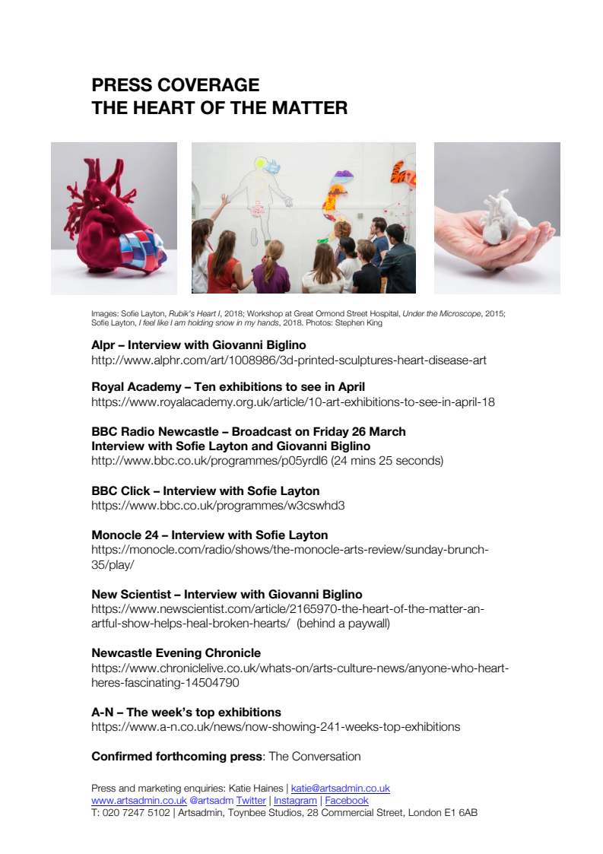

EDUCATION

1982-1985 | BA (Hons) Creative Arts (2:1)  Nottingham Trent University, Nottingham, UK  Including exchange programme with New York State University with a focus on art history, ceramics and sculpture

2018 - 2019 MRes – Royal College of Art

TEACHING

2004-2015 | Visiting Lecturer  London College of Fashion, UAL, London, UK  Including working on the tech effects course (puppetry and object manipulation)
1997-1999 | LIFT – London International Festival of Theatre  London, UK  Artist mentoring scheme
1991-1994 | Winter school for performing arts  Kerala, India  Performing arts programme for international students
1991-1994 | WOMAD – World of Music Art and Dance  International programme across Japan, Finland and UK  Mask and performance lead artist

